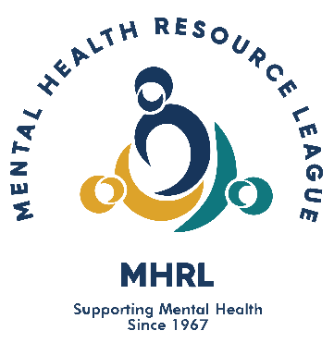
FALL DIDDLEY® CRAFT SHOW -- OCTOBER 12 & 13, 2024

SPONSORED BY: MENTAL HEALTH RESOURCE LEAGUE
FOR McHENRY COUNTY: P.O. Box 204, McHenry, IL 60051
(815) 322-6796 www.mhrl.org

MHRL is a non-profit, all-volunteer organization that raises money through the Fall Diddley® craft show to grant to agencies providing mental health related services in McHenry County. In January, 2023, the League was able to grant over $210,000 to help fund projects and services for 16 agencies in the community.

FALL DIDDLEY® craft show will be held on October 12 & 13, 2024 at the Boone County Fairgrounds in Belvidere, Illinois. Saturday show hours will be 9:00 A.M. to 5:00 P.M. Sunday show hours will be 9:00 A.M. to 4:00 P.M. Saturday set up time will be 6:00 A.M. to 8:30 A.M. Early Set-up is available for Friday, October 11 from 12:00 P.M. to 4:00 P.M. with all crafters and vehicles off the grounds by 7:00 P.M. The Early Set-up fee is $50 payable in advance. There are a limited number of non-motorized storage trailer parking on the grounds available for a $40 fee.

The fairgrounds are a multi-building and tent complex with 24-hour security. We will have over 300 booths. The fee for a 10' x 10' space will be $375 for the two days if paid before 2/15. After 2/15, fees for a 10’ x 10’ space will be $400. Electricity is provided. Motor home hookups are available on the fairgrounds for overnight use and/or parking for an added fee of $50 per night payable in advance. With no advance reservation the fee will be $75 per night. Reservation deadline is September 1st. Pets are not allowed on the fairgrounds.

FALL DIDDLEY
Application deadline: February 15, 2024.

Please include with your contract:

1. 2024 pictures (NO SLIDES / DO NOT EMAIL) -- At least 1 picture must show unfinished craft in process. We are a juried show and your pictures are what help us decide if you are accepted. Please consider that when sending your pictures.
2. Payment (checks will be cashed after 4/15/2024).
3. Business size (#10) self-addressed STAMPED envelope.

Notification of acceptance will be mailed by APRIL 15th. NO refunds once you are accepted. PHOTOS will not be returned. If accepted you will receive a letter of acceptance and your check will be cashed after April 15th.

Please mail application and correspondence to:

FALL DIDDLEY
c/o CRAFT COMMITTEE
PO BOX 204
McHenry, IL 60051

